Updating TRS Contribution Rates

Texas Legislative session changes include increases to three TRS Rates. In response, the TRS Rates table will need to be changed in NY Payroll in order to budget for these changes accurately.

TRS Info:

The recently completed 2019 Texas Legislative Session passed two bills that will impact TRS reporting and will likely require software providers to update programming for their customers. A summary of the changes are as follows:

Applies to all Reporting Entity (RE) types:

- Effective 9/1/2019, the state contribution rate increases form 6.8% to 7.5%. This new rate will apply to all TRS eligible compensation paid on or after 9/1/19
- Over the next five fiscal years, the State Contribution rate, Member Contribution rate, and Non-OASDI rate will increase per the chart below, based on when the compensation is paid to the employee, regardless of when it is earned.

For Pay Received on or after: | State Contribution Rate | Public Education Employer (Non-OASDI) Contribution Rate | Member Contribution Rate
9/1/2019 | 7.5% | 1.5% | 7.7%
9/1/2020 | 7.5% | 1.6% | 7.7%
9/1/2021 | 7.75% | 1.7% | 8.0%
9/1/2022 | 8.0% | 1.8% | 8.0%
9/1/2023 | 8.25% | 1.9% | 8.25%
9/1/2024 | 8.25% | 2.0% | 8.25%

Summary of other legislative changes by RE type:

Independent School Districts:
- Changes to Non-OASDI:
  - Effective 9/1/2019, all REs who pay Social Security on their TRS eligible employees will also be required to pay 1.5% of all TRS eligible compensation to TRS. (This is currently known as the RE Payment for Non-OASDI Members. (REs) who paid Social Security on TRS eligible employees were previously exempt from this contribution.)
    - ISDs will pay the 1.5% on eligible salary up to the state minimum if the position is subject to Statutory Minimum
    - ISDs will pay 1.5% on all eligible salary if the position is not subject to Statutory Minimum
- Changes to Statutory Minimum:
  - Effective 9/1/2019, ISDs who are subject to paying the state contribution on salary paid above the state minimum will no longer use a Cost of Education Index multiplier to calculate an Adjusted State Minimum salary. The state contribution will be due on all eligible compensation paid above the state minimum salary schedule as set by the Texas Education Agency.

Education Service Centers:
- Changes to Non-OASDI
  - Effective 9/1/2019, all REs who pay Social Security on their TRS eligible employees will also be required to pay 1.5% of all TRS eligible compensation to TRS. (This is currently known as the RE Payment for Non-OASDI Members. (REs) who paid Social Security on TRS eligible employees were previously exempt from this contribution.)

Action to take in TxEIS:

In Next Year Payroll, from Tables > Tax/Deductions > TRS Rates tab, enter 2020 in the School Year and Retrieve. Enter the following rates and Save.

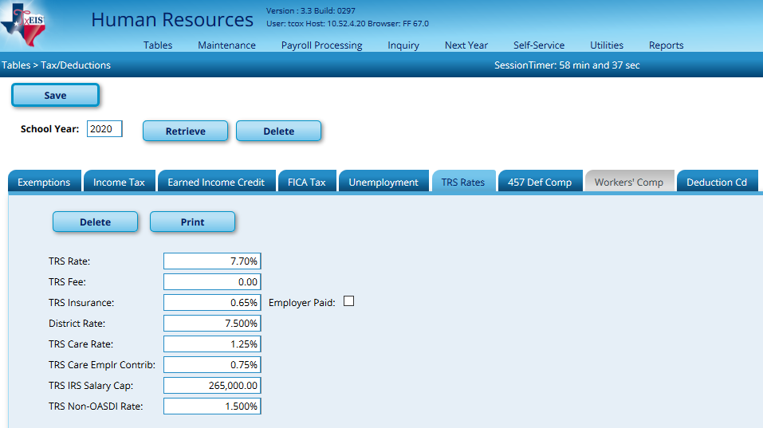

To see the difference this will make in your budget, go to Next Year > Interface NY Payroll to NY Budget. Set your TRS On-Behalf Expenditure Account to whatever you use during the Payroll process when you interface TRS On-Behalf, Enter the Starting Accounting Period for the Finance Fiscal Year (9) and pull all employees over to the right. Run the Extract.

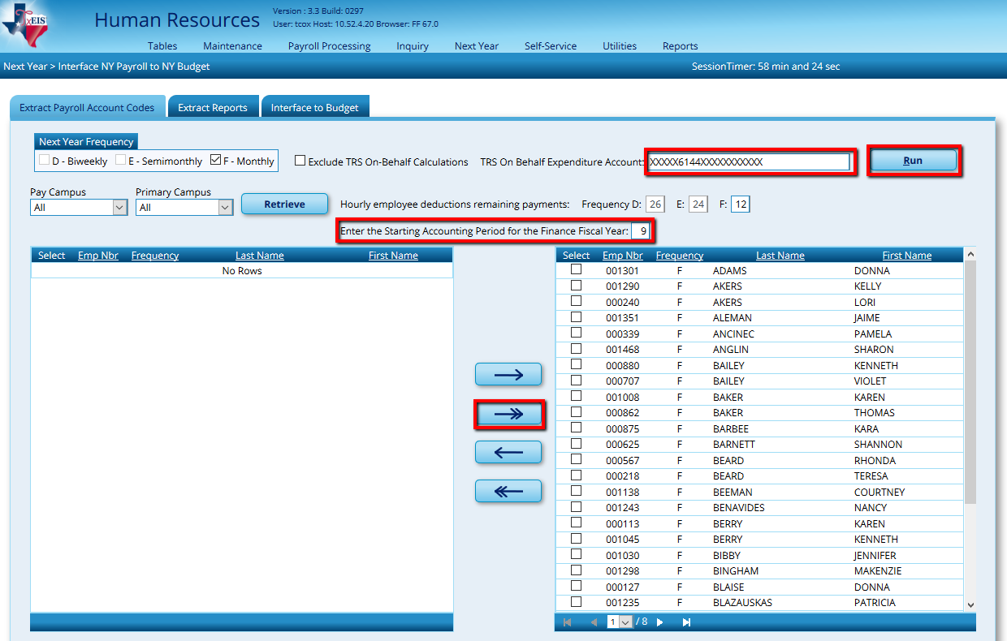

A preview report will give any failures or warnings encountered. Remember that if any employee shows a failure, his/her salary will not be included in the reports you’ll view next. Warnings will still be included, but you may need to double check the accuracy of those totals. Close the preview and proceed to the Extract Reports tab. Select and generate the Next Year Payroll Employee Distribution report.

Continue to the Interface to Budget tab to interface the new figures when you are ready.

Because TRS Rates will change over the course of several years, we will include the updates to each field in the table when it is time for that change.

